Connection Pool Statistics

Java Technologies (Hw. 6)

For this experiment we have integrated in our glassfish sever configuration a connection pool for PostgreSQL.

On server side we created a servlet in order to fulfill requests.

On client side we have a Java application which creates a predefined number of threads. In order to have the best results we added a *CountDownLatch,* a tool that helps us send request at “exactly” same time.

1. 32 connections – 100 requests at same time – without closing connections
   1. Server side failure:

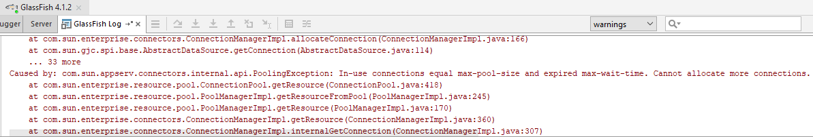

* 1. Client side failure

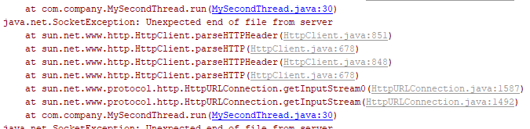

No error has been found if we increase the number of connections to exceed number of requests.

1. 32 connections – 10000 requests at same time – closing connections

No errors have been found if we close each connection after each request.

1. Singleton connection

Using just one connection will result in connection refused exception because a servlet thread is trying to acquire the database connection which can be occupied at a given moment.

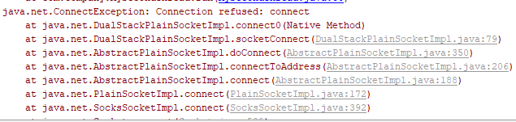

In case of requests <1000 no failures have been detected so far but for large number of requests e.g. 10000 we have detected around 50-500 failures.